Computer Aided Education in Physics by using Double Pendulum Equipment

Mitsuo Suzuki, Mitsuhiko Toho¹, Atsushi Minato and Satoru Ozawa
Graduate School of Science and Engineering, Ibaraki University
Polish-Japanese Institute for Information Technology¹
msuzuki@fukushima-nct.ac.jp, toho@pjwstk.waw.pl, minato@base.ibaraki.ac.jp, ozawa@base.ibaraki.ac.jp,

Abstract
In university level physics classes, the double pendulum demonstration was carried out to introduce an idea of mechanical chaos into students. The motion of the double pendulum was monitored by a video camera. The recorded image data was analyzed on a computer by using software developed by the authors. Chaotic motions were observed while the system had enough energy. The energy of the double pendulum easily dissipated due to friction at hinges and air resistance and the lifetime of the chaos was short. In order to see a “pure” chaotic state in longer period, computer simulation technique was utilized. Computer simulations precisely reproduced the real experiments where the energy dissipation was taken into account. It has been shown in the computer simulations that pure chaotic motions are seen in limiting cases where the energy dissipations are negligible. The monographic description of the motion of double pendulum covers some elements of experimental physics, theoretical physics and computational physics. It is concluded that computer aided education in physics presents a powerful method that is free from experimental and mathematical limitations. The material prepared here is easily converted into digital content of VOD system and is used for remote teaching.

- Introduction
During the last decade, we experienced quite rapid development in information technologies (IT) and related electronic techniques. We are now able to use in classes digital movie cameras, multimedia computers, digital presentation devices and high-speed computer network system with various data processing and managing software. With the aid of these new tools, the method of education in university is now changing very quickly. As an example, a project of constructing a “virtual campus” or “E-campus” is now being carried out at Ibaraki University. As shown in Fig. 1, 1Gbps LAN with various content servers and remote teaching systems supports university campus activities and 100Mbps LAN lines connect the distanced three campuses. Beside the high-speed LAN, commercial ISDN lines and a satellite system (SCS) connect the university with the other universities and also with various organizations in the area. Of course, the introduction of good hardware for “virtual campus” or “E-campus” is important. It should be noted however that individual efforts of teaching staffs toward improvement of their teaching methods in classes with the aid of the IT tools are very much important, because just introduction of the IT hardware does not automatically produce any improvement in education.
The aim of this study is to show an example of a new teaching method that utilizes recently developed IT tools and to discuss problems related to “E-education”. The topic described in this paper is rather special, but the discussion about “E-education” is universal and will be applied to other subjects.

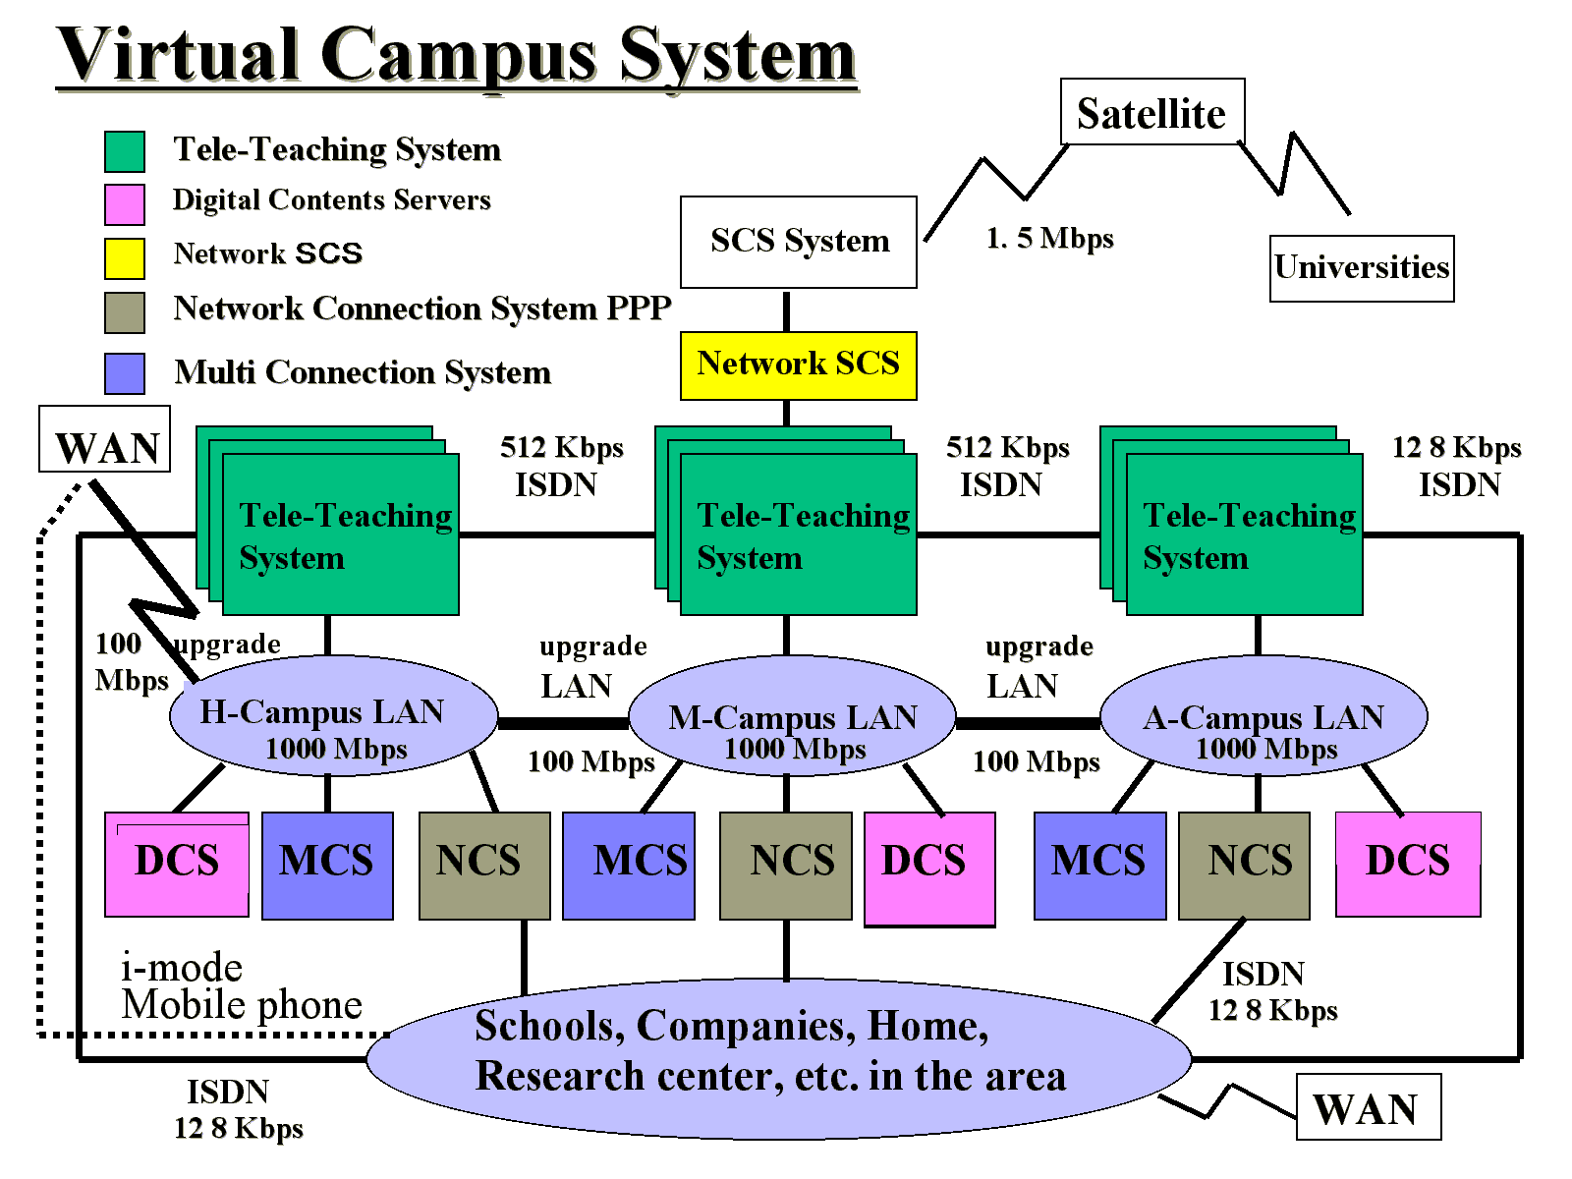
Fig. 1 E-campus system at Ibaraki University

- How to change teaching method in classes
In any fields of sciences, observation is the most important step that should come first. In order to introduce an idea of “chaos” into students, professors should begin their lecture with a suitable demonstration of chaotic phenomena. The good observation attracts student’s interest and they are naturally introduced into the topic. The lecture should not begin with a flood of mathematical expressions even if the essence of chaos is described in mathematical terms.
The demonstration of double pendulum motion can be a good material for introducing an idea of chaos in classes at university level [1-4]. Students will be surprised to see that so much complicated motion is produced from the simple mechanical structure of double pendulum. But it should be noted that the double pendulum system shows chaotic motion while the system has enough energy. The system easily loses its energy due to frictions at hinges and air resistance. The lifetime of the chaotic motion is short. In another word, it can be said that the curtain of the energy dissipation easily veils the true feature of chaos. The authors of this paper try to see the “pure chaotic motion” as long as we want.
One method to improve the demonstration would be to develop a frictionless system, i.e. the frictionless hinge and the experiment in vacuum. The experimental improvement can be an interesting topic in education, but in general the heavy experimental setup for the improvement would not suit with the demonstration in classes. Further, it would be difficult to find a “completely pure chaotic motion” in this direction because the complete frictionless system is impossible to be realized. In the present paper, computer simulation based on “real experiment” is proposed in order to see the ideal chaotic state. This is a quite different approach from commonly done computer simulations that are based on “mathematics” or “mathematical model”.
In the first part of this paper, observation of double pendulum motion is described where the video camera coupled with a computer is utilized to record its motion. Special software has been developed by the authors for analysis of the image data of the motion of double pendulum [5]. In the second part, Lagrange’s equations approach describing the double pendulum motion is presented, where the energy dissipation being taken into account. The structure parameters such as the inertial momentum of each bar of the double pendulum, the friction coefficient of the ball bearing hinge and the air resistance coefficient were determined in supplemental experiments. Once these parameters are decided, complete simulation of the double pendulum has become possible when we integrate the Lagrange’s equations of motion by using a suitable numerical method. We can reproduce the motion of the double pendulum on a computer display, whatever conditions of the energy dissipations are adopted. The student will find that pure chaotic state really exists in a limiting case where the damping effect is negligible. It is important for student to understand that “chaos” exists in the real world and is not a production of mathematical models. In the last part of this paper, it is pointed out that a particular problem of analyzing the motion of double pendulum provides good materials of university level physics which includes some experimental techniques, image data computer processing, theoretical formulation in terms of analytical mechanics, numerical analysis, modern aspect of classical mechanics, etc. The material covers three important categories of physics, i.e. experimental, theoretical and computational. The material is suited for digital contents and can be used for remote teaching by Web + VOD + Database.
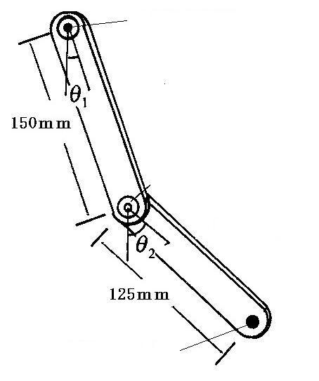
lower bar
red marker mmmmmmarker
hinge with red marker
hinge with green marker
upper bar
Fig. 2 Structure of double pendulum

- Observation of double pendulum motion
Figure 2 shows the schematic of the double pendulum. It is composed of two brass bars, the upper bar and the lower bar. They are 25 mm wide and 3 mm thick. The length of the upper bar and the lower bar is 150 mm and 125 mm, respectively. A ball bearing hinge connects the two bars.

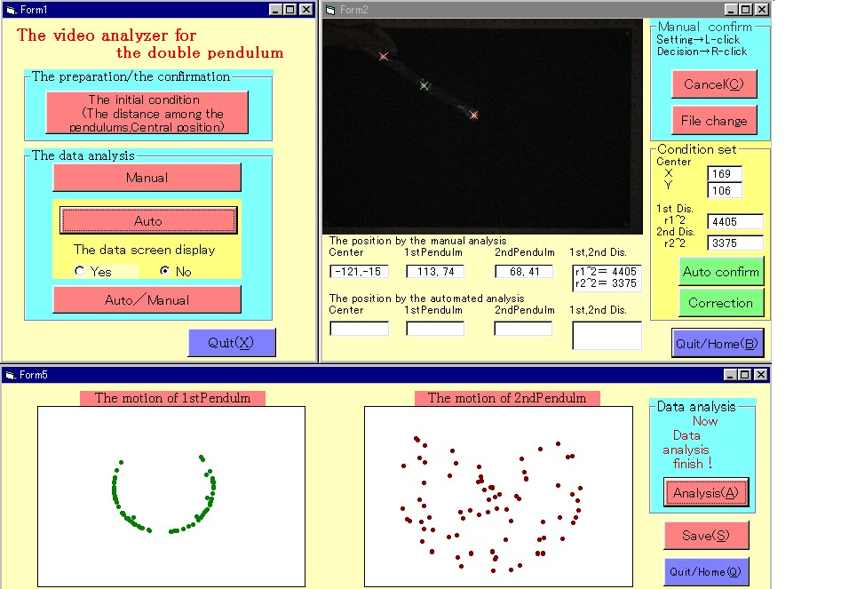

Fig. 3 Analysis of bit map image data on computer

Another ball bearing hinge on the top of the upper bar fixes the double pendulum in space. Green and red markers are placed to indicate the positions of the hinges and the bottom position of the lower bar. The movement of the double pendulum is recorded by a digital video camera at a rate of 30 flames per second.
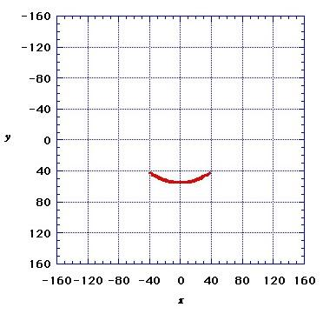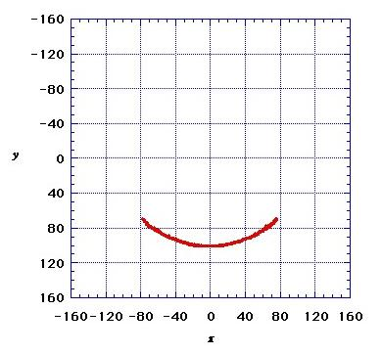
Case (a), upper bar
Case (a), lower bar
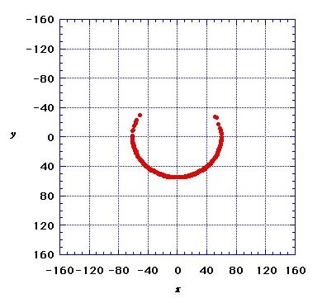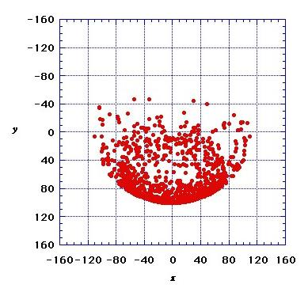
Case (b), upper bar
Case (b), lower bar
Fig. 4 Traces of markers on the upper and the lower bars of the double pendulum that were produced from the different typical initial states, (a) a low energy state $θ_{1}=θ_{2}=\text{40}°$ and (b) a high energy state $θ_{1}=θ_{2}=\text{110}°$.

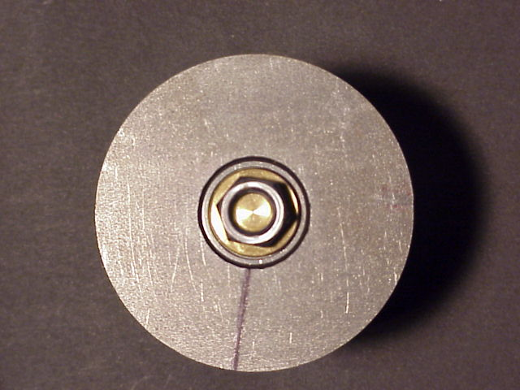
(a)
(b)

Fig. 5 (a) Experimental setup for the measurement of friction at the ball bearing hinge and (b) top view of the ball bearing hinge and the brass circle plate to give a suitable inertia of rotation

By using a nonlinear video editing system, needed parts of the video data were selected and stored in a computer as AVI format files. Then, by another video editing software, the files were converted into bit map image (360×240 pixels) files. The positions of the green and the red markers on the bit map images were recognized automatically by image analysis software developed by the authors. Figure 3 shows the operation of the software. One of the bit map images is on the top main windows. The position data of the upper and lower bars obtained from a series of bit map images are represented in the two bottom windows. The angles $θ_{1}, θ_{2}$ and the angular velocities ${\overset{˙}{θ}}_{1}, {\overset{˙}{θ}}_{2}$are determined as a function of time from the image analysis.
Figure 4 shows examples of the experimental data of the double pendulum motions that were started from the two typical initial states, (a) a low energy state $θ_{1}=θ_{2}=\text{40}°$, ${\overset{˙}{θ}}_{1}={\overset{˙}{θ}}_{2}=0$ and (b) a high energy state$θ_{1}=θ_{2}=\text{110}°$, ${\overset{˙}{θ}}_{1}={\overset{˙}{θ}}_{2}=0$. It is seen from the figure that the motion of the double pendulum is complicated in the case (b); while in the case (a) the motion looks almost harmonic. The details of the bit map image analysis are given separately [5]. It should be noted that the computer analysis of the experimental data provides some good materials for the education of modern techniques of experimental physics.

- Measurement of energy dissipation
The chaos in the double pendulum motion was observed only when the system had enough energy. The energy of the double pendulum easily dissipated due to friction at hinges and air resistance. The lifetime of the chaos was short. For the convenience of numerical analysis of the motion of the double pendulum, the energy dissipation was studied experimentally rather in detail. The experimental setups are simple and are suited for demonstrations in classes.
Figure 5(a) shows the experimental setup used for the measurement of friction at the ball bearing hinge. A brass circle plate was fixed to the hinge to give a suitable inertia of rotation. The top view is shown in Fig. 5(b).
Angular velocity (rad/sec)
Time (sec)
Fig. 6 Experimental data of the measurement of friction force at the ball bearing hinge.

The rotation of the plate was monitored by a digital video camera and the angular velocity was measured as a function of time. The data obtained is shown in Fig. 6. It has been found from the experiment that the friction force at the hinge does not depend on the rate of rotation. This fact is to be used in analysis of the motion of the double pendulum.
Figure 7 shows the measurement of air resistance acting on one of the bars of the double pendulum. A thin thread suspended the bar vertically. An air blower produced a constant air stream. The mouth of the blower [A] is seen in Fig. 7. The suspended bar declined due to air stream. The declining angle against the vertical line was measured as a function of the velocity of air stream. Thus, the air resistance force was determined by the simple experiment. As shown in Fig. 8, the magnitude of air resistance force is proportional to square of the stream velocity. This fact is also used in the analysis of the motion of the double pendulum.

Fig. 7 Experimental setup for the measurement of air resistance. The label [A] shows the mouse of the air blower.

Air resistance force (N/m)
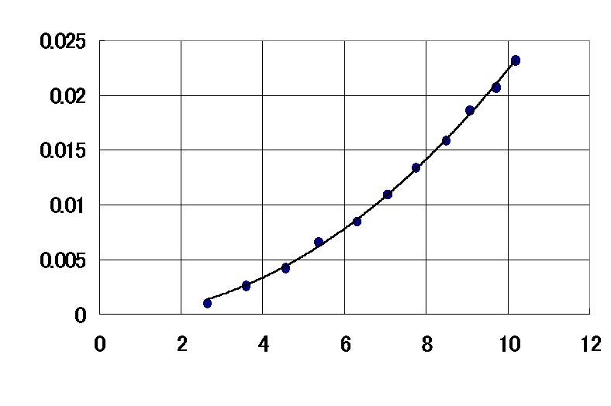
Velocity of air stream (m/sec)

Fig. 8 Experimental data of the dependence of the air resistance force on the velocity of air stream

5. Analysis of the motion of double pendulum
Figure 9 shows parameters describing the geometry of the double pendulum. Here, the mass of the upper bar and the lower bar is m₁ and m₂, respectively. The lengths are l₁ and l₂. The positions of the center of mass of the bars are expressed by the distances h₁ and h₂. The configuration of the pendulum is expressed by the angle θ₁ andθ₂. And g is the gravity constant.
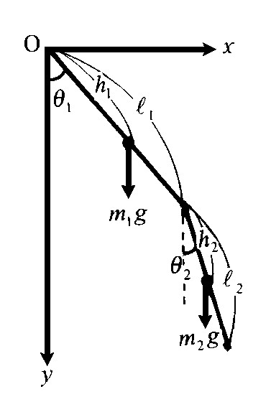
Fig. 9 Parameters of the double pendulum.

The kinetic energy T₁ of the upper bar and that T₂ of the lower bar are
$T_{1}=\frac{1}{2}I_{1}{\overset{˙}{θ}}_{1^{2}}$ (1)
$T_{2}=\frac{1}{2}I_{2}{\overset{˙}{θ}}_{2^{2}}+\frac{1}{2}m_{2}\left({\overset{˙}{x}}_{G^{2}}+{\overset{˙}{y}}_{G^{2}}\right)$ (2)
where I₁ is the moment of inertia of the upper bar about the hanging point O, while I₂ is that of the lower bar about the point of the center of mass. The parameters x_{G} and y_{G} are coordinates of the center of mass of the lower bar. They are expressed by
$\begin{aligned}x_{G}=l_{1}\text{sin}θ_{1}+h_{2}\text{sin}θ_{2} \\ y_{G}=l_{1}\text{cos}θ_{1}+h_{2}\text{cos}θ_{2} \text{.}\end{aligned}$ (3)
The potential energy U₁ of the upper bar and U₂ of the lower bar are expressed by
$U_{1}=−m_{1}{\text{gh}}_{1}\text{cos}θ_{1}$ (4)
$U_{2}=−m_{2}g(l_{1}\text{cos}θ_{1}+h_{2}\text{cos}θ_{2})$. (5)
The Lagrangian L is
$\begin{aligned}L=T_{1}+T_{2}−U_{1}−U_{2} \\ \frac{1}{2}I_{1}{\overset{˙}{θ}}_{1^{2}}+\frac{1}{2}I_{2}{\overset{˙}{θ}}_{2^{2}}+\frac{1}{2}m_{2}\left\{l_{1}^{{}^{2}}{\overset{˙}{θ}}_{1^{2}}+h_{2^{2}}{\overset{˙}{θ}}_{2^{2}}+2l_{1}h_{2}{\overset{˙}{θ}}_{1}{\overset{˙}{θ}}_{2}\text{cos}(θ_{1}−θ_{2})\right\} \\ +m_{1}{\text{gh}}_{1}\text{cos}θ_{1}+m_{2}g(l_{1}\text{cos}θ_{1}+h_{2}\text{cos}θ_{2})\text{.} (6)\end{aligned}$
The dissipation function $K=K_{1}+K_{2}$ is used to express the energy dissipation due to friction at hinges and air resistance. The dissipation function related to the friction at hinges is
$K_{1}=C_{1}|{\overset{˙}{θ}}_{1}|+C_{2}|{\overset{˙}{θ}}_{2}|$. (7)
Here, $C_{1}$and $C_{2}$ are constants which can be determined in the experiment described in section 4. The dissipation function related to the air resistance is
$K_{2}=\frac{1}{3}D_{1}{\left\{1+\frac{l_{2}}{l_{1}}|\text{cos}(θ_{1}−θ_{2})|\right\}}^{3}|{\overset{˙}{θ}}_{1}|^{3}+\frac{1}{3}D_{2}|{\overset{˙}{θ}}_{2}|^{3} \text{.}$ (8)
Here, $D_{1}$and $D_{2}$ are constants which can be determined experimentally. The equations of motion are obtained from the formula,
$\frac{d}{\text{dt}}\left(\frac{∂L}{∂{\overset{˙}{θ}}_{i}}\right)−\frac{∂L}{∂θ_{i}}+\frac{∂K}{∂{\overset{˙}{θ}}_{i}}=0 (i=1, 2) \text{.}$ (9)
Therefore, the equations describing the motion of the double pendulum are,

$\begin{aligned}{\overset{¨}{θ}}_{1}+D_{1}μ_{1}{\left\{1+\frac{l_{2}}{l_{1}}|\text{cos}(θ_{1}−θ_{2})|\right\}}^{3}|{\overset{˙}{θ}}_{1}|{\overset{˙}{θ}}_{1}+ω_{1^{2}}\text{sin}θ_{1} \\ +m_{2}μ_{1}l_{1}h_{2}\text{sin}(θ_{1}−θ_{2}) {\overset{˙}{θ}}_{2^{2}}+m_{2}μ_{1}l_{1}h_{2}\text{cos}\left(θ_{1}−θ_{2}\right) {\overset{¨}{θ}}_{2} \\ +C_{1}μ_{1}\frac{{\overset{˙}{θ}}_{1}}{|{\overset{˙}{θ}}_{1}|}=0 (\text{10})\end{aligned}$
$$\begin{aligned}{\overset{¨}{θ}}_{2}+D_{2}μ_{2}|{\overset{˙}{θ}}_{2}|{\overset{˙}{θ}}_{2}+ω_{2^{2}}\text{sin}θ_{2}−m_{2}μ_{2}l_{1}h_{2}\text{sin}\left(θ_{1}−θ_{2}\right) {\overset{˙}{θ}}_{1^{2}} \\ +m_{2}μ_{2}l_{1}h_{2}\text{cos}(θ_{1}−θ_{2}) {\overset{¨}{θ}}_{1}+C_{2}μ_{2}\frac{{\overset{˙}{θ}}_{2}}{|{\overset{˙}{θ}}_{2}|}=0, (\text{11})\end{aligned}$$
where,
$$\begin{aligned} μ_{1}=\frac{1}{I_{1}+m_{2}l_{1^{2}}}, μ_{2}=\frac{1}{I_{2}+m_{2}h_{2^{2}}}, \\ ω_{1^{2}}=\frac{m_{1}h_{1}+m_{2}l_{1}}{I_{1}+m_{2}l_{1^{2}}}g\text{, } ω_{2^{2}}=\frac{m_{2}h_{2}}{I_{2}+m_{2}h_{2^{2}}}g \text{.}\end{aligned}$$

- Computer simulation
The fourth order Runge-Kutta method was used for the numerical integration of the equations of motion of the double pendulum. The parameters in the equations can be determined from the energy dissipation experiments described in section 4. It is worthwhile to note that the computer simulation can be carried out under any conditions including the real experimental condition with the energy dissipation and the ideal condition that the energy dissipation is completely eliminated. In order to see “pure chaotic” motions of the double pendulum, the ideal condition was noted. Two typical cases were examined where the pendulum motion started from the states (a) $θ_{1}=θ_{2}=\text{40}°, {\overset{˙}{θ}}_{1}={\overset{˙}{θ}}_{2}=0$ (low energy initial state) and (b) $θ_{1}=θ_{2}=\text{110}°, {\overset{˙}{θ}}_{1}={\overset{˙}{θ}}_{2}=0$ (high energy initial state). Figure 10 shows the energy of the upper bar and that of the lower bar as a function of time. It is seen that the both fluctuate but the sum of them remains constant. The total energy of the system conserved. Figure 11 shows trajectories obtained from the motion of the upper bar for the typical cases (a) the low energy state and (b) the high energy state.

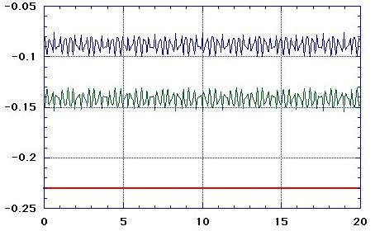
Energy (J)
(a)

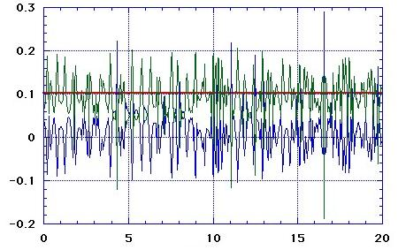
Time (sec)
(b)

Fig. 10 Energy of the upper bar (blue line), that of the lower bar (green line) and sum of the two (red line) for the two typical states (a) and (b), see in the text.

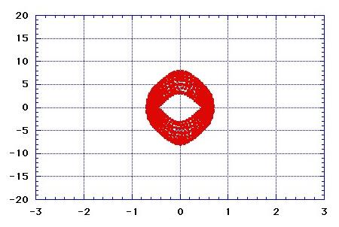
Angular velocity (rad/sec)
(a)
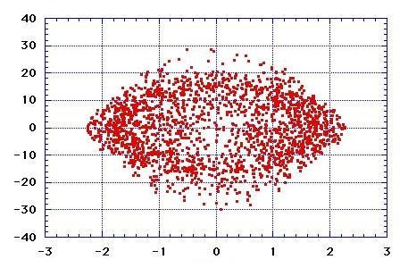
$θ_{1} (\text{rad})$
(b)

Fig. 11 Trajectory of the upper bar, $θ_{1}$vs $\overset{˙}{θ_{1}}$ for the above said typical cases (a) and (b), see in the text.
It is seen that the trajectory for (b) is very much complicated, which suggests the motion is chaotic. This is also seen from Fourier analysis of the pendulum motion. Figure 12 shows that the low energy state (a) has a limited number of mode components, while the high energy state (b) has a plenty of components.

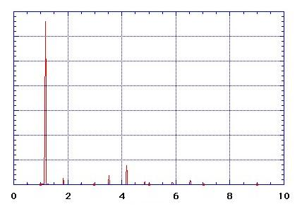
Power spectrum (Arbitrary unit)
(a)
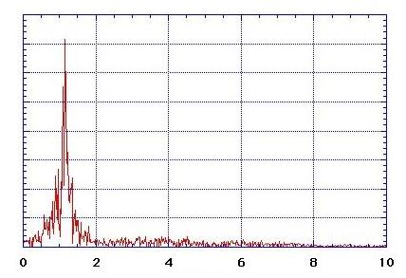
Frequency (Hz)
(b)

Fig. 12 Fourier analysis of the motion of the upper bar for the typical cases (a) and (b), see in the text.

- Discussions
Due to recent developments in IT and related electronic techniques, the method of education in university is now changing very quickly. Let us discuss here about “future university education system” in the following points.
(A) New media for education
The main material that has been commonly used so far in classes is textbook. The digital book (E-book) or any other forms of digital content will be given to students in future university classes, where various types of new media (DVD, CD, IC memory stick, etc.) and new communications (mobile computer, cable TV, internet mobile phone, space satellite system, etc.) will be used. The advantages to use digital contents are; (1) multimedia type information (movie and audio) is easily inserted into text base information, (2) links between elements of content make it possible to do “net surfing like study”, and (3) interactive learning between students and computers can be realized. In the context of the topic of this paper, let us describe these advantages concretely. Movies of the demonstration experiment and the computer simulation of the double pendulum will be easily inserted into the text base explanation. For the students who is not familiar with the Lagrange’ equations, the dissipation functions, Runge-Kutta method, etc., the material should have many links to supplemental explanations on these items. By the computer simulation program of the double pendulum that should be included in the material, student can learn about chaos interactively with computer.
(B) Flexible forms of education
Use of digital contents automatically produces flexibility in education. The interest of students and their level of knowledge are very much varied. The mass education does not work nowadays unless it is improved by IT techniques. The “net surfing like study” by digital contents can introduce multiple courses in one class. The success of this idea depends upon whether we can prepare or not a very good material that has a plenty of helpful links. Another flexibility produced from digital contents is “whenever and wherever learning”. With the aid of digital contents, student can learn by themselves. The place of study is not limited to university campus.
(C) Role of professor
The considerable amount of professor’s works, especially routine works, will be replaced by intelligent computer’s work. University level education will be carried out on computer network systems. Then, the most important role of professors will be to produce good digital contents. In order to do this, professors should change their teaching method by using IT techniques as is just described in this paper. Another important work of professors will be discussions with students. The university campus will become a place of “human care” or “human relationships” in which various types of communications between students and university staffs will be taken. Social programs will be important as well as academic programs

References
[1] T. Shimbrot, C. Gregogi, J. Wisdoman and J. A. Yorke, ”Chaos in a double pendulum”, Am. J. Phys., 60 (1992), pp. 491-499.
[2] R. B. Levien and S. M. Tan, ”Double pendulum : An experiment in chaos,” Am. J. Phys., 61 (1993), pp. 1038-1044.
[3] R. L. Kautz, ”Chaos in a computer-animated pendulum”, Am. J. Phys., 61 (1993), pp. 407-415.
[4] H. Nagshima and Y. Baba, “ Introduction to chaos”, Baifukan, Tokyo, 1992, pp.144-148, in Japanese.
[5] M. Suzuki and K. Masuda, ”Chaotic motion of a double pendulum”, PESJ, 48 (2000), pp.1-5.

